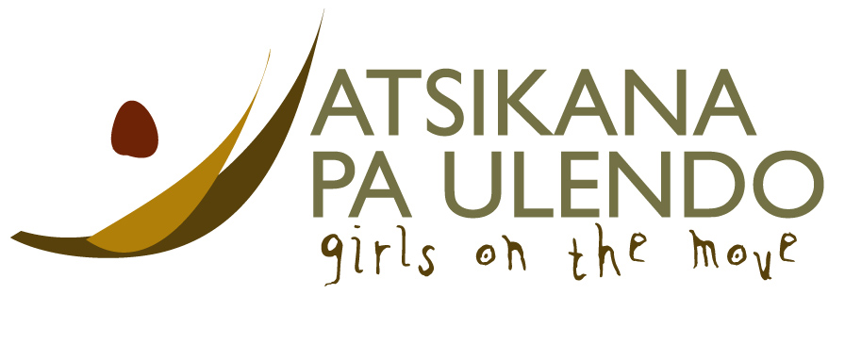
MINUTES
APU – MEF Board of Directors Meeting
Tuesday, April 19, 2016
Held via GoToMeeting.com

In attendance: Helene Weir (Chair), Christie Johnson (Executive Director), Pat Killoran (Treasurer), David Stocks, Lori Messer, Dean Rohrs, Tricia Timmermans (Secretary)

- Call to Order
The meeting was called to order at 1802 PT/ 1902 MT.

- Approval of Agenda.
Addition of an update on Society status by Pat. Approved as amended.

- Approval of Minutes of February 23, 2016.
M/David, S/Dean that the Minutes of February 23, 2016 be approved as distributed. APPROVED

- Business Arising from February 23, 2016 Minutes.
  - Letter to Malawi Trust re: Myles Boonstra and Mark Kinzel.
Christie reported that the Trust would have its next meeting on May 22. The letter will be discussed at this meeting. Myles and Mark will attend the meeting. They will be attending an Investors’ conference in South Africa and have invited Memory, Henry and Christie to speak at this conference. They will donate $5,000 to APU. Memory and Henry will make a presentation, with travel and accommodation costs covered.
  - APU Teacher Professional Development at U of Lethbridge – progress report.
Pat reported that Wyson has spoken well to a couple of Rotary clubs, and has done a fundraiser in the Education Department at the University. The program is very useful for Wyson. He has asked him to document what he has learned, in particular what could be useful to him/APU in Malawi. Discussion on Lethbridge nurses who visit Malawi, and whether they could be encouraged to go to the hospital near APU. A Vocational Training Team could teach first aid, etc. at APU. Lori has invited Wyson to visit the West Coast.
  - Funds Development Committee Report.
(See APU FD Plan August 2016-July 2017 document distributed with meeting documents)
Helene spoke re the need to raise $200,00+ between now and the end of the 2017 school year. Student numbers’ projection is 95 (down from 110). The $241,000 capital needed stems from the Program Definition V13c. Discussion on whether to cut back on expenditures in favour of keeping teachers, and on the order of priorities, but Christie explained it is not a prioritized list. Henry sent a list of needed items that would qualify for the Global Grant. Replacement items were not included on the list. Christie understands the operating budget is being used for such things as replacement mattresses. It was decided that a list should be developed for further fundraising at such gatherings as the Zone Institute – a “Project-to-do” list. The shortfall ($40,000) does not include donations from Rotary clubs that regularly give. Pat is working on the Rotary partner in Malawi, which has “gone quiet”, in an attempt to keep the club responsive and accountable. The Rotary Zone institute people will be the best source for raising money. Christie will give a list of donor names to Helene and Tricia so that follow-up can be done regarding donations/sponsors. ACTION CHRISTIE. At present, the CRA audit takes precedence. Wyson’s visit to Vancouver Island could be a potential fundraising connection. Esther will be hosted by the Dawson Creek Rotaract Club before she leaves for home on June 13, which also could have fundraising possibilities. The Christmas Giving request would be more beneficial if sent out in October rather than December. Re the https://chuffed.org/project/apufood4work campaign, of 111 donors, approximately 15 were new. Tax Receipts will be sent out at the end of the campaign (May 25). (As of May 3, $34,246 has been raised towards the food for work project.)

- Executive Director’s Report

Financial Status

Capital Funds on hand at end of March = $72, 221l

 | Funds Raised To Date | Funds Already Wired | Funds On Hand | Funding Projection to July 31
Food For Work  (33,000) | $29,168 | $7,500 | $21,668 | $3832  (misc. pledges)
Legacy Phase 2  ($150,000) | $70,553 | $20,000 | $50,553 | $18,700  ($8,700 RC pledges, $10,000 DC Interact)
Science Materials |  |  |  | $10,000  RC Calgary Downtown
Primary Class Block #2  $40,000 |  |  |  | $40,000  Women Helping Women
Security Project  $22,000 |  |  |  | $22,000  RC Calgary West $ RC Olds

Food For Work
- $33,000 raised with $29,168 already in our account
- Wired $7,500 on March 11
- Requesting a further $15,000 wired Monday, April 25
- >900 people employed to date
- 4 weeks of work remaining to those in need
- Famine situation exacerbated by people eating their crops prior to harvest (green maize) making the harvest far less than expected. Hungry season expected to hit harder and earlier next year.
- Considering saving $10,000 of the raised funds to purchase maize at cheap price to store for a similar project next year. To be discussed by APU Trust. Directors felt that in order to be true to the donors, the road should be finished ASAP. Henry should be made aware of the necessity of staying on track and finishing the road. If funds are needed because of bad crops next year, we will meet that concern at the time. ACTION CHRISTIE

Legacy Phase 2
- $70,553 raised with another $19,000 expected by July 31st.
- Wired $20,000 on Feb 29th
- Raised a total of $70,000 with $19,000 still to come
- Raised $90,000 out of $150,000.
- Need to raise a further $60,000 to complete this project!
- Request a further $20,000 wired Monday, April 25

Operating Funds on hand at end of March = $56,400

- Expect to finish the 2015/2016 school year with $47,000 in the account
- If MEF sponsors 95 students (down from 110 this year), these funds should last through to the end of Feb of next year. This is a 6 month lead time.

Donor Relations
- Sponsorship mail-out – 90% in the mail. Lori and family worked with Christie on this.
- Database Rollover finalized
- Wyson’s speaking engagements
- Security Project – District Grant headed by RC Calgary West
- Science Supplies – RC Calgary Downtown
- Dawson Creek Interact Club fundraiser – Esther Mwale
- June speaking tour

News From the School
- Form Fours Sitting for mock exams
- Bedbug infestation. Whole school had to be sent home while buildings were ‘zapped’.
- M&H both have had Malaria
- Update on the ‘mothers’ situation – things have calmed down and Memory is more at ease.
- Graduation Date and Plans
- Library, Computer Lab

- New Business
    - CRA Audit. Christie has not yet been provided with a list of documents that CRA will require. Pat has no concerns re CRA audit. We should not be too worried, and we may learn some things. One area where we should improve is in reconciliation between revenue vs. what we send out in tax receipts. As we go forward, we need to have discussion between those involved on how this is done. Lori feels that Christie should just answer the questions, and not give the big story. The more you flush out an answer, the more avenues there are to be pursued. Thanks to Lance and Tricia for work on the Crowdfunding project.

    - August Retreat. Most directors thought August was too early and that it could be held every other year. It was suggested we do a Strategic Plan review instead of a retreat via conference call.
- Treasurer’s Report.

Discussion was held on dates for the AGM. It should be conducted in October rather than December to comply with Society Act, which changes at the end of November in BC. (Check this link for more information.) If we have an AGM soon, we will be back on track and in compliance with the Act. A date will be arranged before the end of October.

8) Current Bank Balance – APU MEF
$136,219.67

9) Adjournment at 7.52 PM Pacific, 8.52 PM Mountain

Next meeting
Next Board meeting on Tuesday, 17th May, 2016 at 6/7PM. Meeting in June is slated for June 21st. PLEASE MARK YOUR CALENDARS.

__________________________________
Minutes prepared by: Tricia Timmermans

Approved at the APU directors meeting on

